Q1: Transform RGB values manually into corresponding HSI values.

Assume

1- rgb(255, 0, 0)

Transformation :

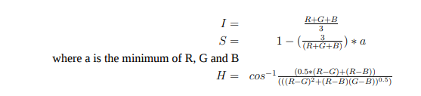

I =(255+0+0)/3=85

S = 1- (3/255 )\*0 =0

H =cos^-1 (.5 \*255\*255)/(255^2+0) =60

2-rgb(255, 255, 255)

I=(255+255+255)/3 =255

S =1-(3/(3\*255)\*255 =0

H=cos-1(0) =90

Q2:

Color matching studies carried out in the 1920s by British researchers John Guild, W. D. Wright, and others, showed that colored samples could be matched by combinations of monochromatic primary colors Red (700 nm), Green (546.1 nm) and Blue (435.8 nm). The average responses of a large group of observers could be reproduced by a set of three matching functions. While purely additive combination of the three primaries could match only the range of hues in the triangle shown below, all the colors could be matched by adding a certain amount of red to the color being compared. This corresponds to negative values for the red matching function as shown. From the matching functions, one can derive tristimulus values which specify the chromaticity.

About those negative values:

520nm is an example of a bright green that wasn’t achievable with the test primaries unless a negative amount of red was used.

The 1931 Standard Observer is only valid for colors viewed at a 2° field of view. This places the light on a spot on the back of your eye called the Fovea. This is a spot with high cone density, giving you maximum color discrimination and limited rod interference.

Color researchers realized that a 10° color matching function would be more representative of day to day color perception so color matching experiments were repeated at 10° and published as the 1964 10° Supplementary Standard Observer.

